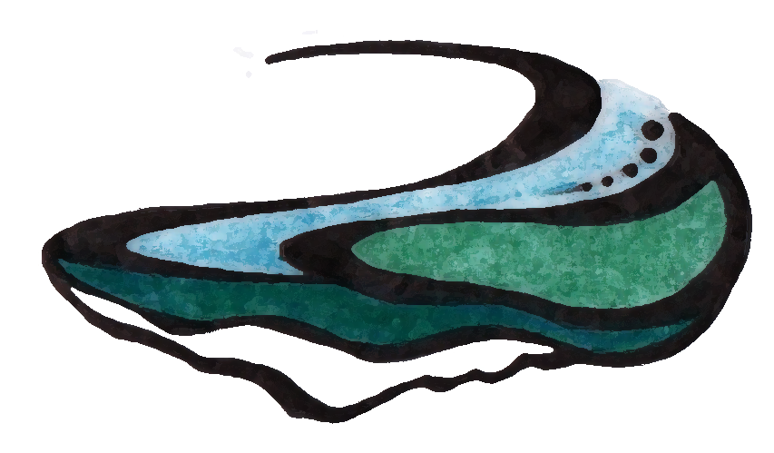
Luke Boyer, DC
Chiropractic Physician
Complementary Sports Medicine

Name ___________________________ Home phone _____________ Work phone _________
Address _____________________________________________________________________
Email address ________________________________________________________________
Date of birth __________ Gender (circle): M F Marital status ________ No. of children ____
Name of partner ___________________________ Referred by _________________________
Have you ever seen a Chiropractor? No Yes (Who?): ____________________________
Insurance
Employer: __________________________ Occupation: ______________________________
Subscriber name: ___________________ Birthdate: ___________ Relationship: ___________
Health plan: ______________ Subscriber ID: _____________ Group number: _____________
Accident Information
Is this consultation due to an accident? □ Yes □ No If so what was the date of the accident: ________ Type of accident: □ Auto □ Work □ Home □ Other
Did you file an accident report or police report? □ Yes □ No

Chief complaint ______________________________________________________________
Have you seen other health care provider(s) for this condition? No Yes (explain): ______
____________________________________________________________________________
Have you tried over the counter medication for this condition? No Yes (explain): ______
____________________________________________________________________________
Were any diagnostic images taken for this complaint? No Yes (circle below):
X-ray CT scan MRI Ultrasound Other (explain): _____________________
Has your condition affected your daily activities? No Yes (explain): ___________
____________________________________________________________________________
Does you condition affect your sleep? No Yes (explain): ____________________________________________________________________________
How long have you had this condition? _____________________________________________
Have you had this or similar conditions in the past? ___________________________________
Is this problem getting worse? ______Constant? _____Worse in morning? ______Evening?___
Is this interfering with work? _____________________________________________________
What do you believe is wrong with you? ____________________________________________
What are your concerns about this condition? ________________________________________________
List other problems you have now_________________________________________________
____________________________________________________________________________
List past operations and dates ____________________________________________________
____________________________________________________________________________
Have you ever been hospitalized other than surgery? _________________________________
Have you ever had any mental or emotional disorder? _________________________________
Have you had any other injury in the past two years? __________________________________
Are you taking medications? _________ Describe ____________________________________
____________________________________________________________________________
Are you taking nutritional supplements? _________ Describe ___________________________
____________________________________________________________________________
Are you allergic to any foods, drugs, etc? ___________________________________________
Do you have any dental problems? __________ Dr.: __________________________________
Do you wear arch supports? _________ Heel lifts? _______ Special shoes? _______________
Have you had any significant head injuries? _________________________________________
Date of your last physical exam? _________ Dr.: _______________________ Blood test? ____
Habits (describe with amounts):
Alcohol ________________________________ Coffee _______________________________
Cigarettes ______________________________Drugs not listed above ___________________
Describe your present exercise habits _____________________________________________
Please list the main health problems in your family:
Relation: Problem: ____________________________________________________________________________________________________________________________________________________________________________________________________________________________________
In case of emergency, please list the name and number of a friend or relative:
____________________________________________________________________________
Your signature: ___________________________________________Date: _______________

In the space provided, please enter “C” if you currently have or “P” if you have had this problem
General EENT Cardiovascular
_______ Excess weight gain/loss _______ Poor vision _______ Irregular heart beat
_______ Bleeding problems _______ Loss of vision _______ Pain over heart
_______ Anemia _______ Eye pain _______ High/low blood pressure
_______ Diabetes _______ Deafness _______ Previous heart trouble
_______ Cancer _______ Nosebleeds _______ Myocardial infarction
_______ Thyroid disease _______ Sinus problems _______ Ankle swelling
_______ Alcoholism _______ Hoarseness _______ Varicose veins
_______ Drug abuse _______ Tonsillectomy _______ Rheumatic fever
_______ HIV risk factor _______ Colds/flu _______ Poor circulation
_______ Chills _______ Ear problems _______ Rapid/slow pulse
_______ Fainting _______ Sore throats Neurologic
_____ Fever Respiratory _____ Weakness
_______ Insomnia _______ Difficulty breathing _______ Twitching
_______ Nervousness _______ Chronic cough _______ Tremors
_______ Depression _______ Spitting up blood _______ Headaches
_______ Sweats _______ Spitting up phlegm _______ Dizziness/Vertigo
Genitourinary ______ Wheezing/Asthma _______ Epilepsy
_______ Frequent urination _______ Pneumonia _______ Mental disorder
_______ Painful urination _______ Tuberculosis _______ Partial or complete paralysis
_______ Blood in urine Other Musculoskeletal
______ Kidney disease _______ Tropical infection _______ Arthritis
_______ Urinary infection _______ Parasitic infection _______ Foot trouble
_______ Breast lump or pain Gastrointestinal ______ Hernia
_______ Venereal disease _______ Appendicitis _______ Low back pain
_______ Sexual difficulty _______ Poor digestion _______ Neck pain
_______ Prostate problems _______ Difficulty swallowing _______ Poor posture
Skin _______ Vomiting blood _______ Sciatica
_______ Itching _______ Pain over abdomen Pain/Numbness in:
______ Bruises easily _______ Ulcer _______ Shoulders
_______ Changes in mole(s) _______ Bloody stool _______ Arms
_______ Skin cancer _______ Liver problems _______ Elbows
_______ Boils _______ Gallbladder problems _______ Wrist/Hand
_______ Dryness _______ Jaundice _______ Hips
_______ Loss of bowel control _______ Legs
_______ Diarrhea _______ Knees
_______ Constipation _______ Feet
For women only: _______ Menstrual problems _______ Hot flashes
Date of last period: __________ _______ Irregular cycle _______ Menopausal symptoms

Informed consent
I, _____________________, the undersigned have voluntarily requested that Dr. Luke Boyer assist me in the management of my health concerns. I understand that Dr. Boyer is a chiropractor and that his services are not to be construed or serve as a substitute for standard medical care. Dr. Boyer recommends that I undergo regular routine medical check-ups by medical doctor.
Medical doctors, doctors of chiropractic, osteopaths, and physical therapists who perform manipulation are required by law to obtain your informed consent before starting treatment.
I, _____________________, do hereby give my consent to the performance of conservative noninvasive treatment to the joints and soft tissues. I understand that the procedures may consist of manipulations/adjustments involving the movement of the joints and soft tissues. Exercise and nutritional counseling may also be used.
Although spinal manipulation/adjustment is considered to be a safe and effective form of therapy for musculoskeletal problems, I am aware that there are possible risks and complications associated with these procedures as follows:
Soreness: I am aware that like exercise it is common to experience muscle soreness in the first few treatments. There also may be occasional slight bruising and tenderness following certain manual therapy techniques.
Dizziness: Temporary symptoms like dizziness and nausea can occur but are relatively rare. Please inform Dr. Boyer if you experience these symptoms.
Fractures/Joint Injury: I further understand that in isolated cases underlying physical defects, deformities, or pathologies like weak bones from osteoporosis may render the patient susceptible to injury. When osteoporosis, degenerative disc, or other abnormally is detected, this office will proceed with extra caution.
Stroke: Although strokes happen with some frequency in our world, strokes from chiropractic adjustments are rare. I am aware that nerve or brain damage including stroke is reported to occur once in one million to once in ten million treatments.
A thorough health history and tests have been performed on me to minimize the risk of any complication from treatment and I freely assume these risks.
Treatment results: I also understand that there are beneficial effects associated with these treatments including decreased pain, improved mobility and function, and reduced muscle spasms. However, I appreciate there is no certainty that I will achieve these benefits. I realize that the practice of medicine as well as chiropractic, is not an exact science and I acknowledge that no guarantee has been made to me regarding the outcome of these procedures. I agree to the performance of these procedures by my doctor and other person of the doctor’s choosing.
Alternative Treatments Available: Reasonable alternative to these procedures have been explained to me including rest, home applications of therapy, prescription or over-the-counter medications, exercises and possible surgery.
Medications: Medications can be used to reduce pain or inflammation. I am aware that long term use or overuse of medication is always a cause for concern. Drugs may mask pathology, produce inadequate or short-term relief, undesirable side-effects, physical or psychological dependence, and may have to be continued indefinitely. Some medications may involve serious risks.
Rest/Exercise: It has been explained to me that simple rest is not likely to reverse pathology, although it may temporarily reduce inflammation and pain. The same is true of ice, heat, or other home therapy. Prolonged bed rest contributes to weakened bones and joint stiffness. Exercises are of great value, but are not corrective of injured nerve and joint tissues.
Surgery: Surgery may be necessary for conditions such as joint instability or serious disk rupture, among others. Surgical risks may include unsuccessful outcome, complications, pain or reactions to anesthesia, and prolonged recovery.
Non-treatment: I understand the potential risks of refusing or neglecting care may include increased pain, scar/adhesion formation, restricted motion, possible nerve damage, increased inflammation, and worsening pathology. The aforementioned may complicate treatment, making future recovery and rehabilitation more difficult and lengthy.
I have read and or have had read to me the above explanation of chiropractic treatment. Any questions I have had regarding these procedures have been answered to my satisfaction PRIOR TO MY SIGNING THIS CONSENT FORM. I have made my decision voluntarily and freely. To attest to my consent to these procedures, I hereby affix my signature to this authorization for treatment.
Patient signature:__________________________________________________
Date: ___________________________________________________________

